**DAILY ONLINE ACTIVITIES SUMMARY**

|  |  |  |  |  |  |  |  |  |
| --- | --- | --- | --- | --- | --- | --- | --- | --- |
| **Date:** | **18/07/2020** | | | | | **Name:** | **SHREEKIRAN R BHAT** | |
| **Sem & Sec** | **IV sem & B section** | | | | | **USN:** | **4AL18CS080** | |
| **Online Test Summary** | | | | | | | | |
| **Subject** | | **-** | | | | | | |
| **Max. Marks** | | **30** | | **Score** | | | **-** | |
| **Certification Course Summary** | | | | | | | | |
| **Course** | **Predictive Modelling and Analytics** | | | | | | | |
| **Certificate Provider** | | | **Greatlearning academy** | | **Duration** | | | **5.5 hours** |
| **Coding Challenges** | | | | | | | | |
| **Problem Statement1:** Reverse words in given string in Python. | | | | | | | | |
| **Status : Yes** | | | | | | | | |
| **Uploaded the report in Github** | | | | | **YES** | | | |
| **If yes Repository name** | | | | | **Lockdown-coding** | | | |
| **Uploaded the report in slack** | | | | | **YES** | | | |

**Online Test Summary: No internals was conducted.**

**Online Certification Course Summary: I have completed another course in Great Learning that is Data Visualization using Tableau and I have received the certificate.**

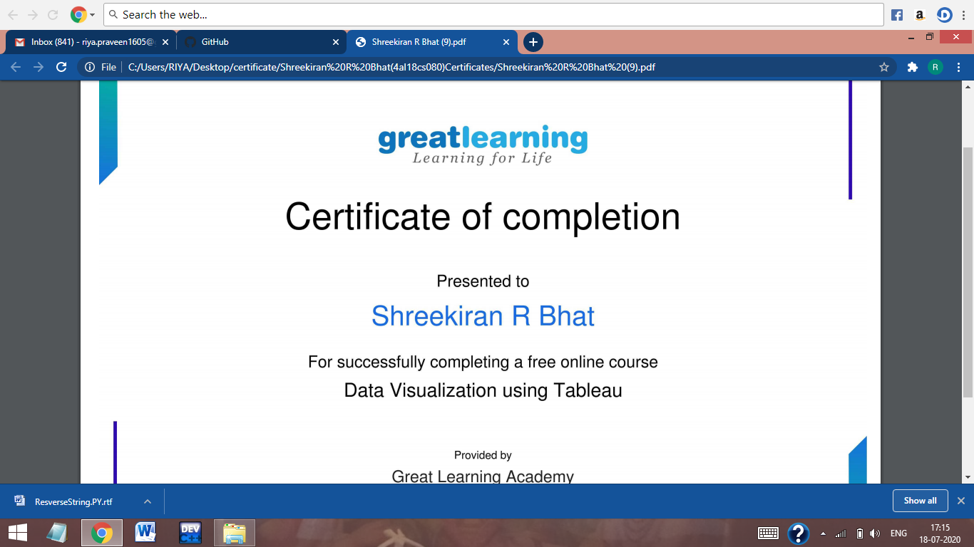

**This is the snapshot of certificate.**

**Online Coding Summary: Todays code was to reverse words in given string in Python given by Prof.Vasudev Shahapur. I have uploaded the code in Github and the repository name is lockdown coding.**

